Network project

NAMES:

Ahmed Mohamed Korany sec: 1 B.N:28

Mohamed anter gad sec: 3 B.N:56

# Lab 2 (TCP performance):

Question 1:

1.1

Average throughput:

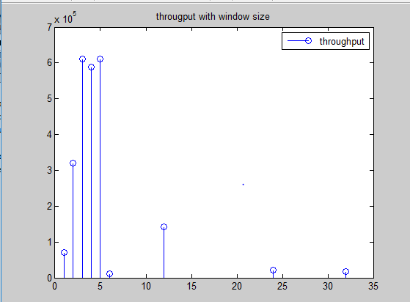

Number of retransmissions:

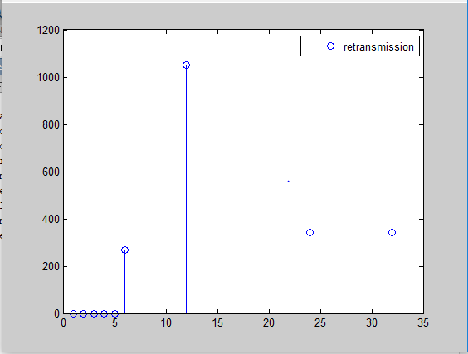

Comment: increasing the window size will increase both the throughput and retransmitted packets until a limit after this limit the throughput will drop (at 6k) and then at 12k will increase again as the retransmitted packets at 12k is less than in 6k.

1.2

Total header bytes = 68 divided as following:

TCP layer: 32 bytes

IP layer : 20 bytes

Ethernet layer: 16 bytes

1.3

For the ack. Packet sent from n11:

TCP layer: 32 bytes

IP layer: 20 bytes

Ethernet layer: 16 bytes

Question 2:

2.1

Throughput of (n7, n8)path = 267500 Bytes/sec which is less than throughput of(n7 to n11)

Comment: the path from n7 to n8 is longer and has multiple switches in the path, on the other hand the path from n7 to n11 is shorter so its throughput is larger.

Question 3:

3.1

Case (A) : throughput = 512500 Bytes/sec

Case (B) : throughput = 267500 Bytes/sec

Case(C) : throughput = 39500 Bytes/sec

Case b is better than c because of the loss in ( c ) and retransmitted packets.

3.2

Case (B) : throughput = 267500 Bytes/sec

Case(C) : throughput = 39500 Bytes/sec

Case(D) : throughput = 14100 Bytes/sec

Case b is the best because zero percent loss and no retransmitted packets.

In case c and d retrasmitted packets are 92 , 73 respectivly.

3.3

Case (e) : throughput = 365000 Bytes/sec

Case(f) : throughput = 262500 Bytes/sec

Case (e) is better because the route from n7 to n11 is forward from n5 to n4 and case (e) has zero loss in this direction.

# Lab 3 (OSPF performance):

Question 1:

1.1

After step 3 path will be:

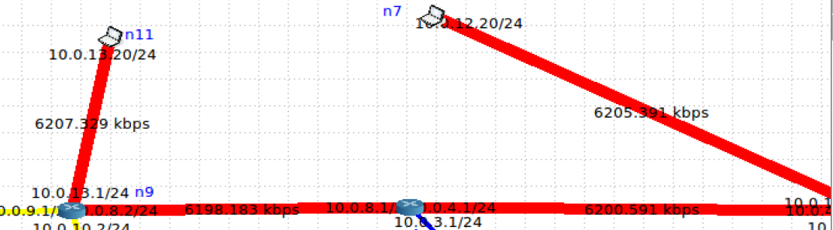

After step 6 :

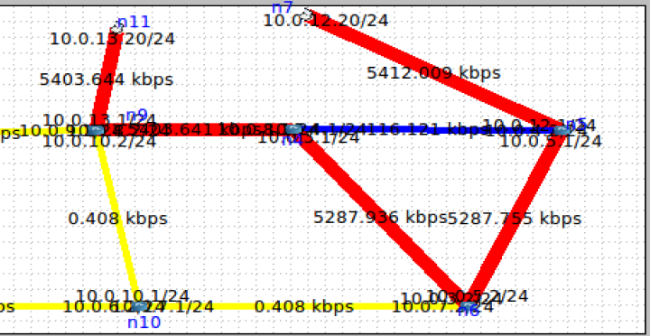

Comment:

After making the cost 40 of eth1 the path changes with different numbers of bytes in each link.

1.2

Establishing iperf3 connections:

A) connection from n7 to n11 :

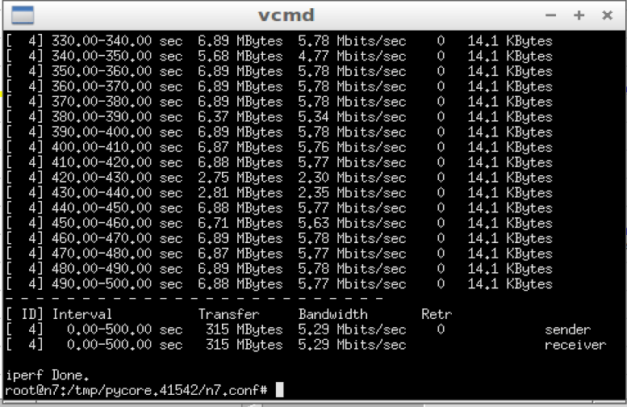

B) connection from n11 to n7:

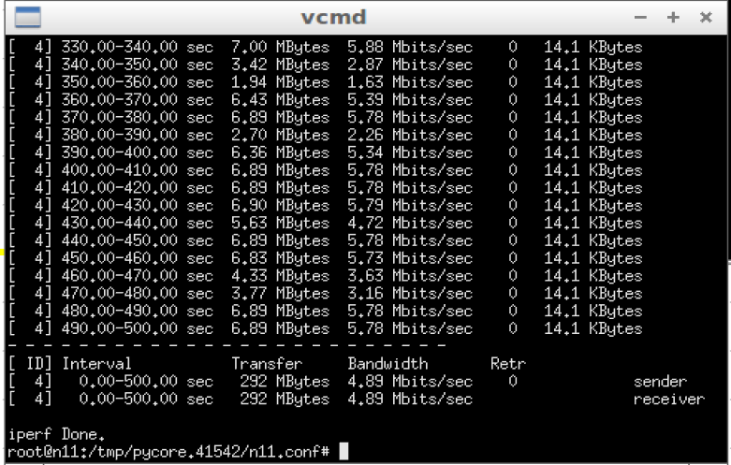

Path between n7, n11 when cost = 10:

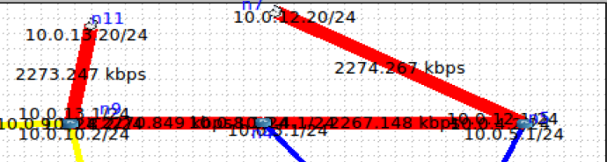

Path between n7, n11 when cost = 40:

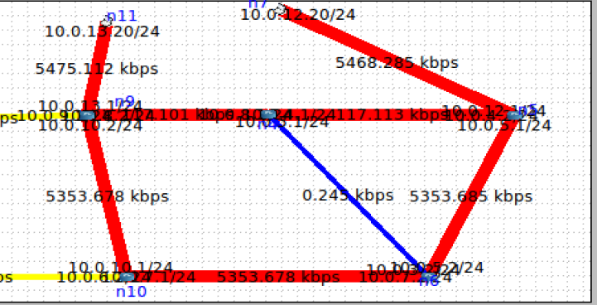

Path between n11, n7 when cost = 40:

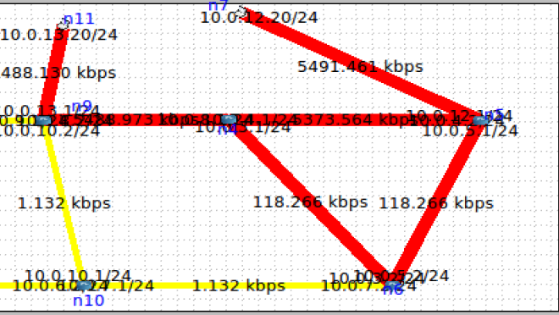

Comment : After changing the cost of n5, n4 connection the path between n7 , n11 becomes longer when cost = 40

Question 2:

2.1

Show ip ospf database:

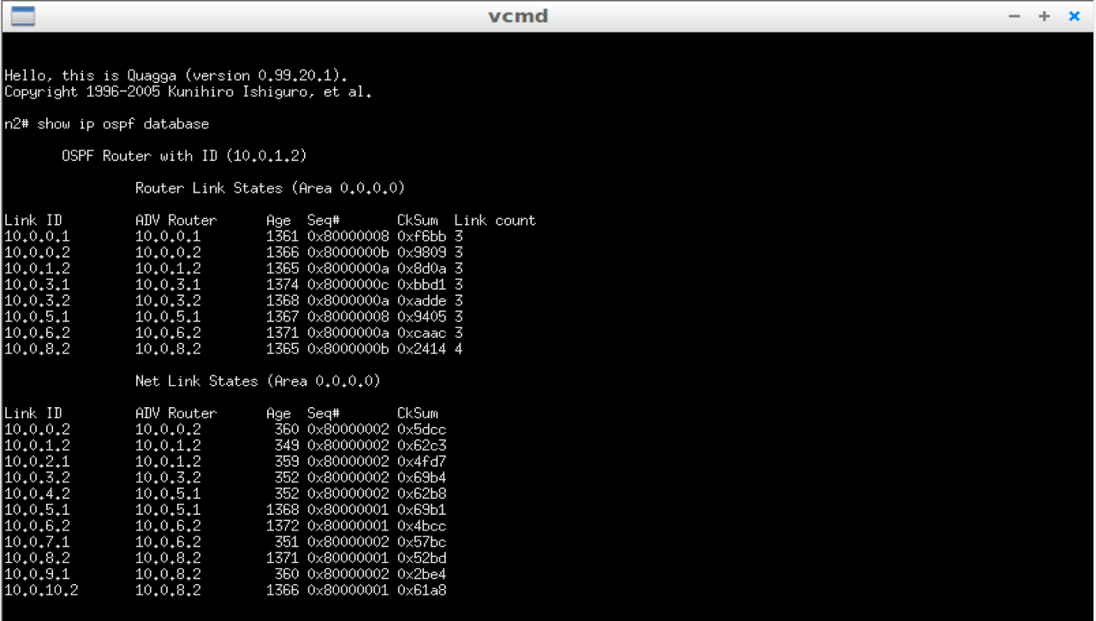

Show ip ospf route:

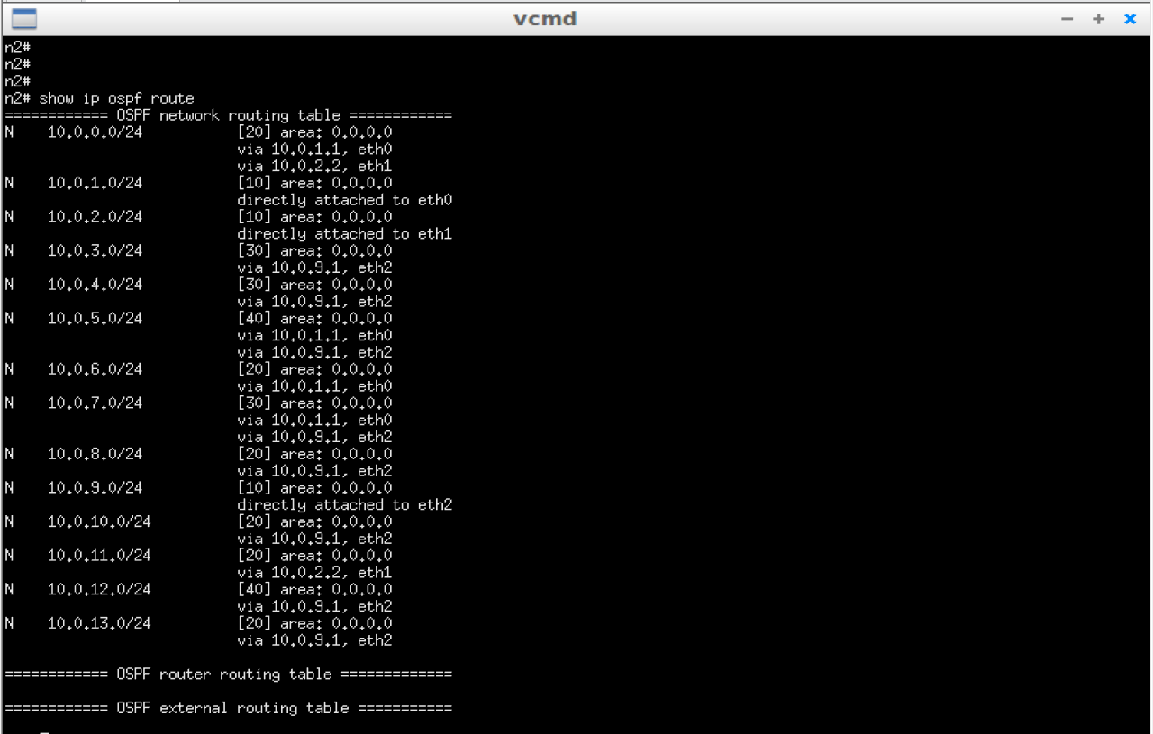

Comment: some destinations have more than route because of congestion occurring in a route

2.2

Time to adjust routing = first update time – last ack. Time

= 40.58 - 20.5 = 20.08 sec

2.3

For n2:

Router database:

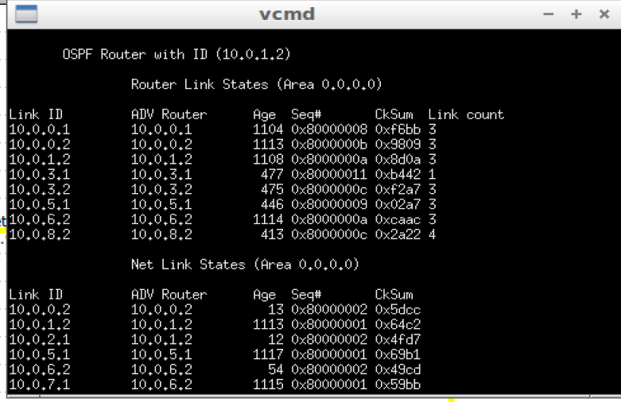

Router route:

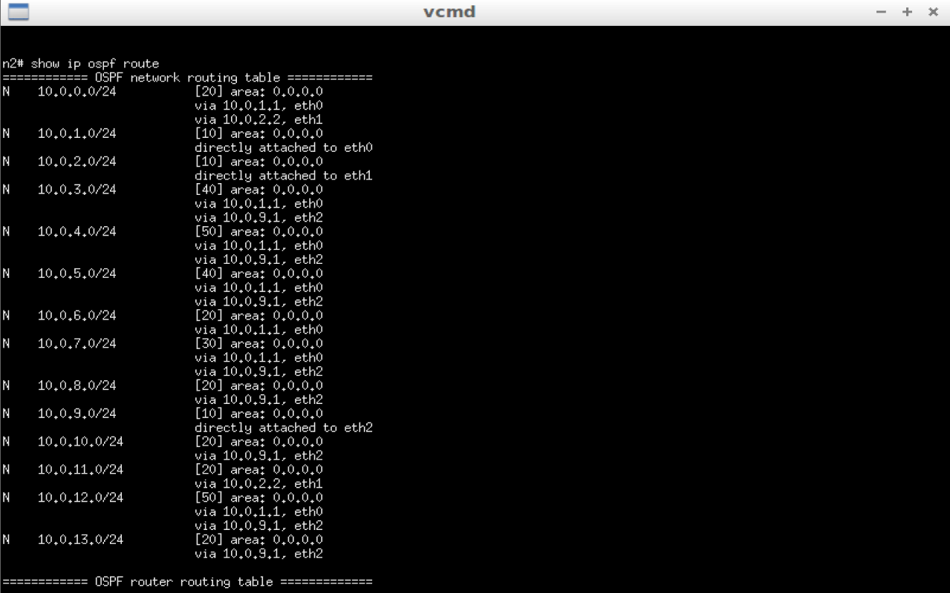

Comment : Route table becomes bigger as there is a router not available in the path and More destinations have more than route as the path will include more switches and become longer.

Question 3:

3.1:

N4 is down: Time to recognize the router is down = Last ack. Time – first update time

= 80.5 - 20.55

=60.04 sec

N4 is up: Time to recognize the router is up = Last ack. Time – first update time

= 480 – 290.7

= 189.3 sec